**Quad Copter Ground Control Station Design Description**

Author: Anton Kypiatkov

Date: 15/02/2020

**Table of Contents**

1. General 4

2. Main Requirements 4

3. Main system components 5

4. Ground control Power distribution and consumption 5

5. Ground controller application design description 6

6. Graphical user interface for the quad controller 7

6.1. General 7

6.2. Quad Status Bar 7

6.3. Quad control Bar 8

6.4. Setup menu 9

6.5. Manual control menu 10

6.6. Auto Control Menu 12

6.7. About menu screen 13

7. Quad Controls and Setup 14

7.1. Quad controls 14

7.2. Quad control setup handling: 14

8. Digital communication link function 16

8.1. General communication system description 16

8.1. Ground control station signal interface 16

8.1.1. General definitions 16

8.1.2. TX message description (Ground station -> Quad) 17

8.1.3. RX message description (Quad -> Ground station) 19

8.1.4. Protocol description 20

8.2. Communication system function description 21

8.3. Communication system electrical assembly 23

8.4. Communication System Mechanical assembly 23

9. Ground Control Initialization – Next chapter to write 23

10. Quad Health Monitor 23

11. Video Link function 23

11.1. Video receiver description 23

11.2. Video link functional description 24

12. Runway recognition function 24

13. Position Estimation function 24

14. Autoland function 24

15. Autoland on runway - TBD 24

16. Automated flight execution 24

17. Mechanical design description – Schematics, assembly, etc… 24

18. Electrical ICD – Wiring DWGs for production... 24

19. List of abbreviations 24

**List of Figures**

**Figure 1 - Quad Computer ground Controller** 5

**Figure 2 - Toolbar and Status Bar** 8

**Figure 3 - Setup Menu** 9

**Figure 4 – Exit Menu** 10

**Figure 5 - Manual control menu** 11

**Figure 6 - Auto control Menu** 13

**Figure 7 - About Menu** 13

**Figure 8 – Digital Communication system architecture** 16

**Figure 9 – Communication protocol timeline** 21

**Figure 10 – Communication system internal data flow** 22

# 

**List of Tables**

Table 1 – Default setup 15

Table 2 – General Message structure 17

Table 3 - States Request Message 17

Table 4 - Manual command message 18

Table 5 - man_command element description 18

Table 6 - Special commands message 19

Table 7 - Special_cmd element description 19

Table 8 – Acknowledge message 20

# General

This document specifies the main specification and design for the ground control station for a short range semi-autonomous quad copter.

# Main Requirements

1. The Ground Control Station shall communicate with the quad copter via a digital control interfaces (C2 link):
   1. The digital control interface shall allow sending flight control commands, i.e. UP/DOWN, YAW, FWD/BACK and LEFT/RIGHT.
   2. The digital control interface shall allow sending complex system commands – going to Nav. Point, flight route, return home, etc.
   3. The digital control interface shall allow the GCS to receive reports as acknowledgments from the quad copter – This will include: Pitch, roll, yaw, throttle, estimated ground speed and estimated position.
   4. The range between the quad copter and the ground control station shall be up to 1Km.
   5. The frequency of the communication system shall be implemented over the publicly available 2.4 GHz frequency.
   6. The data rate for the C2 link shall be at least 100Kbps.
   7. The data within the messages shall be protected with a robust error detection code.
   8. The command and report link shall include a message retry mechanism.
2. The Ground control station shall have a secondary communication link which shall receive a FPV video from the quad copter in real time.
3. The ground control Station shall include an operator control station which shall have the following functionality:
   1. The control station shall communicate with the C2 link via a standard serial interface (USB or serial RS-232).
   2. The control station shall communicate with the video interface via a serial interface (USB).
   3. The control station shall have a user graphical interface, through which the operator shall have the following functionality available:
   4. Show the quad's pitch, roll and yaw in form of an attitude indicator.
   5. Show the quad's reported speed (Vertical and horizontal).
   6. Show the quad's estimated heading.
   7. Show the quad's estimated position and azimuth relative to the takeoff point.
   8. Show the quad's battery voltage status.
   9. Show the communication link status – Show in percentage how many messages were lost.
      1. Show the quads controls – UP/DOWN, YAW, FWD/BACK, LEFT/RIGHT.
      2. Show the FPV video received from the quad + HUD data added to the image.

# Main system components

The following are main system components for the Quad ground controller:

1. **PC** – With a windows based installation. The PC will be running a ground control application which shall implement the above specified requirements.
2. **Communication transceiver** - NRF24L01-PA-LNA wireless module with an attached antenna.
3. **Arduino UNO** – Used as a communication transceiver controller.
4. **Frame grabber** - For video capture - EasyCap with a USB connection.
5. **Video Receiver** – 5.8 GHz receiver.
6. **Battery** - A rechargeable 11.1 VDC, 2,200 mAh Li-po battery as a power source of the video receiver for the ground station.

The connection between the main system components is depicted in **Figure 1 - Quad Computer ground Controller**.

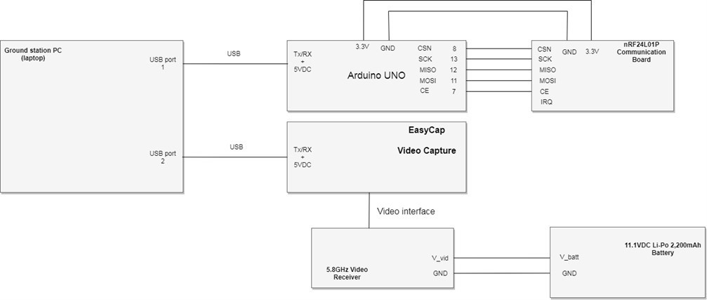

**Figure 1 - Quad Computer ground Controller**

# Ground control Power distribution and consumption

This section addresses the power consumption of the ground controller system. The provided numbers are a continuous worst case power consumption scenario (Maximal power consumption).

Power consumption per sub-component:

1. Arduino UNO maximal power consumption - Estimated at 50[mA] (powered 5VDC). **Note:** Powered via USB port 1 on a laptop PC.
2. NRF24L01P maximal power consumption – Estimated at 15[mA] at transmission time. (Powered by 3.3VDC). **Note:** Powered via a power pin on the Arduino UNO.
3. EasyCap – No data for power consumption. Assume 100mA is used on 5VDC input.
4. Video Receiver – Powered via a Li-po battery. Power consumption is 150mA (max) for a 6.5 – 15[VDC] power supply.
5. Laptop power consumption – Consider maximal GPU and CPU load for intensive graphics processing – **40 Watt**.
6. Hence the estimated total power consumption is specified as:
$Laptop_{P}=Arduino_{P}+EasyC_{P}+nRF24_{P}+HW_{P}=0.25Watt+0.05Watt+0.5Watt+40Watt=40.8Watt$

$Video_{P}=1.65Watt$

7. The total runtime of the system (without being connected to an external power source) is calculated as follows:
   1. The video receiver is connected to a 2,200 [mAh] 11.1VDA LiPo battery (24.42 Watt/h). The video receiver consumption is 1.65 Watt, hence: $t=\frac{battery_{W}}{video_{P}}=\frac{24.2\left[\frac{W}{h}\right]}{1.65\left[W\right]}=14.67\left[hours\right]$
   2. The rest of the system is powered by a Lenovo ideapad 500S battery. The battery is a 30Wh battery. The fully loaded max consumption is 40.8Watts, which means that the operation time is: $t_{laptop}=\frac{30\left[\frac{W}{h}\right]}{40.8\left[W\right]}=0.73\left[hours\right]=44\left[miutes\right].$
   3. It is clear that if the computer is plugged in into a 220AC power source, operation time will be limited only by the LiPo battery for the video receiver.

# Ground controller application design description

The main component of the ground controller is based on a PC laptop. The PC laptop shall be based on an i7 processor, with at least 8GB of RAM and an integrated NVidia GPU with at least 2GB of RAM.

The computer shall have a minimum of two USB ports:

1. One port shall be used to connect the PC to an Arduino UNO microprocessor board (this board handles the control of the communication system). This port shall be used by the PC as a communication port with the quad copter (via the Arduino board).
2. The second port shall be used to connect to a EasyCap device, which captures analog video and translates it to low resolution digital video.

The controller shall be implemented via a custom application, which shall run under a standard windows 7/8/10 environment.

The application shall have the following main functions:

1. Manage ground controller GUI for displaying commands and reports, and handling user inputs via keyboard, joystick and mouse inputs.
2. Manage communication between the transceiver and the quad copter.
3. Capture and display quad video from a video receiver.
4. Log flight data in the ground controllers memory.
5. Perform automated functions:
   1. Displaying quad mode of operation and quad health monitoring
   2. Performing quad initialization
   3. Performing link establishment and link recovery
   4. Automated runway recognition from the quad video stream.
   5. Position estimation based on quad data and video processing (celestial navigation)
   6. Perform an automated flight plan.

The requirements, per each functionality, are discussed in the following sections.

# Graphical user interface for the quad controller

## General

The GUI for the quad ground controller includes the following main control menus:

1. A Setup menu screen – Which handles keyboard configuration, such as keys definition, input sensitivity and Quad test (BIT).
2. A manual control screen – A screen with the quads basic controls, e.g. UP/DOWN, YAW, FWD/BACK, LEFT/RIGHT, and applicable quad reports and video from FPV camera.
3. A Quad auto control menu – Shall allow the user to input an automated flight plan which the quad copter shall perform and perform manual flight corrections.

Additionally, The GUI shall include a status bar and a control bar:

1. A status bar displaying vital quad copter and ground controller information
2. A toolbar allowing the user to navigate the various available menus.

## Quad Status Bar

In all three menus the controller interface shall display – Basic quad status Bar and a toolbar allowing to switch from menu to menu. The status bar shall be located at the top of the screen as depicted in **Figure 2 - Toolbar and Status Bar**.

The status bar shall include the following reports for the quad copter:

1. Quad copter battery status – Battery status shall be displayed in percentage in green color. If percentage is lower than 15%, the color of the status indication shall be changed to red. The value range shall be: 0% to 100%.
2. Mode of operation – The modes of operation report shall include: STBY (standby), MAN (Manual), Auto (Automatic), FAIL (Error mode).
3. Estimated Altitude – This shall show the quad estimated altitude in regard to the ground station. In case the altitude is larger than 50 [meters] the status shall be indicated in red, and a LIM text shall appear next to the reported value. Altitude values shall range from: -1,000 to +1,000 meters.

**Note:** Altitude 0 is the starting height of the quad (Takeoff height)

1. **Link status** – The link status shall be indicated in percentage. The percentage shall be calculated by the percentage of the received ACK messages received vs. the number of command message sent.
2. **Status**:Which reports the failures status of the Quad. NO for normal operation, and the following letters in case of reported failures: G - gyro fail, A- accelerometer fail, H – heading fail, 1/2/3/4 – Engine 1/2/3/4 fail.

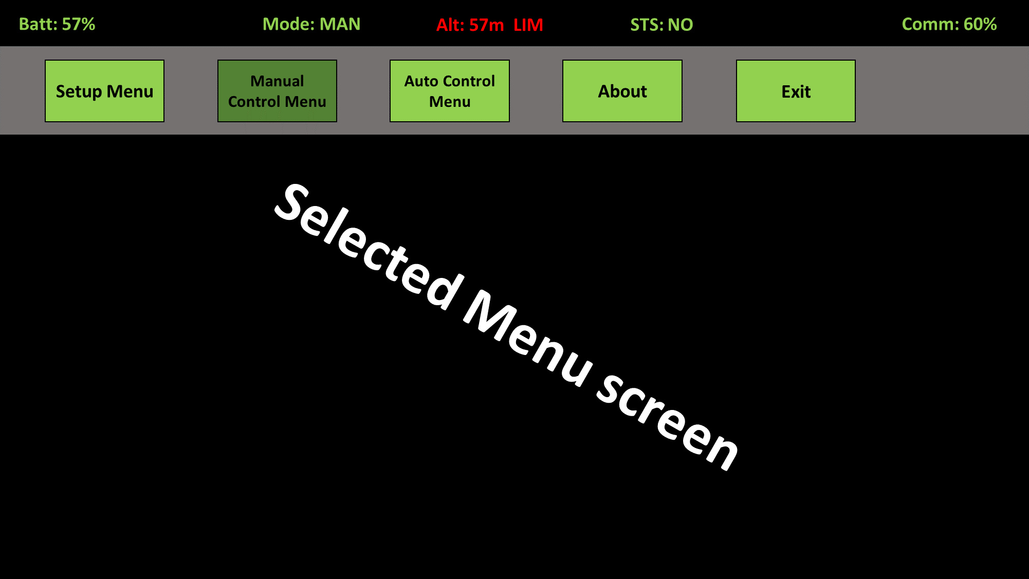

**Figure 2 - Toolbar and Status Bar**

The status Bar is at the top part of the screen, bellow it is the toolbar and bellow the toolbar is the current selected menu.

## Quad control Bar

The toolbar shall be located bellow the status bar as depicted in figure 3.

The toolbar shall include the following four buttons:

1. **Setup** – This button shall open the setup menu screen.
2. **Manual** – This button shall open the manual control screen.
3. **Auto** – This button shall open the auto control menu screen.
4. **About** – This button shall open the about menu screen.
5. **Exit** – This button shall close the quad controller application. Prior to closing the application the user shall be prompted with a yes/no question: “Are you sure you want to exit the application?” (See **Figure 4** )

All the toolbar buttons shall be operated via mouse inputs. Each button shall be pressed when the mouse clicks it with the left mouse button.

The setup/manual/auto buttons shall be operated in latch logic. When a button is clicked the following shall be performed:

1. On mouse down: The clicked button shall change to a darker color; all other toolbar buttons shall be set to a default color and the relevant screen shall appear on the selected menu screen (Auto, Man, setup)
2. The exit button shall be a toggle button. It shall change color on mouse down to a darker color, and shall set back to default color on mouse release. Once pressed the user shall be prompted with a "yes/no" question, whether he wants to terminate the ground controller application or not.

## Setup menu

The setup menu shall enable the user to set various parameters used for controlling the quad copter. The setup menu is depicted in **Figure 3 - Setup Menu**.

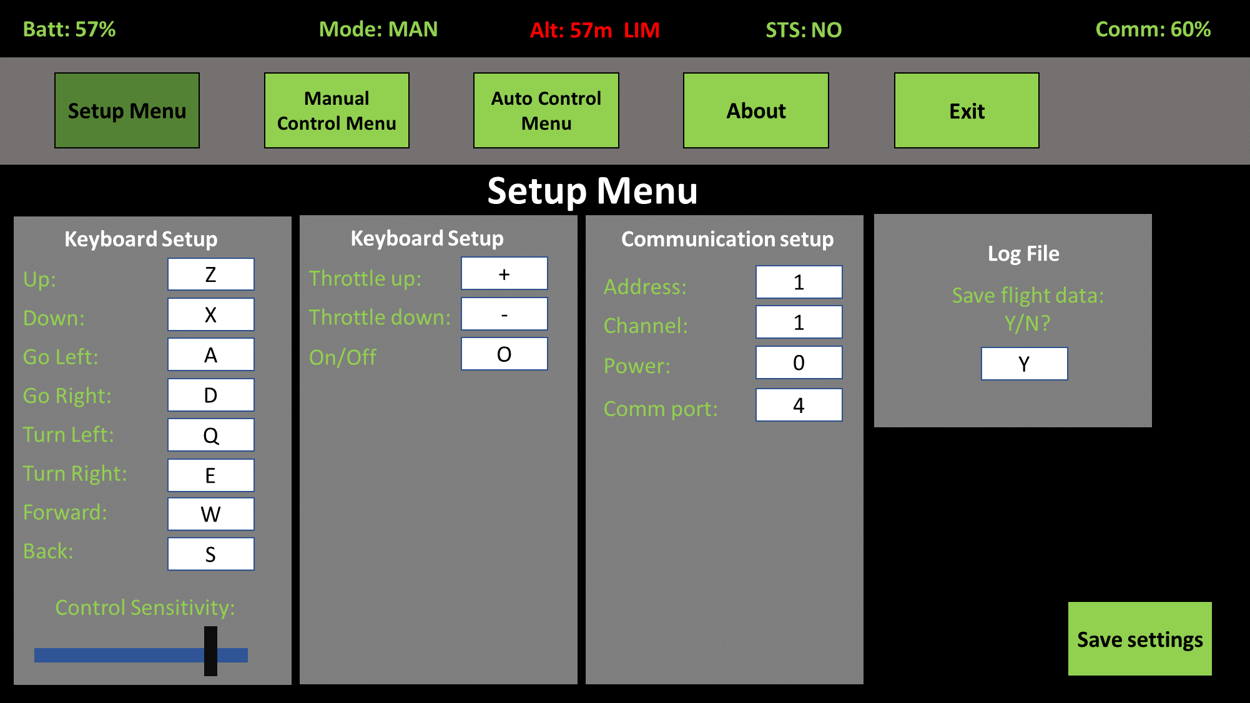

**Figure 3 - Setup Menu**

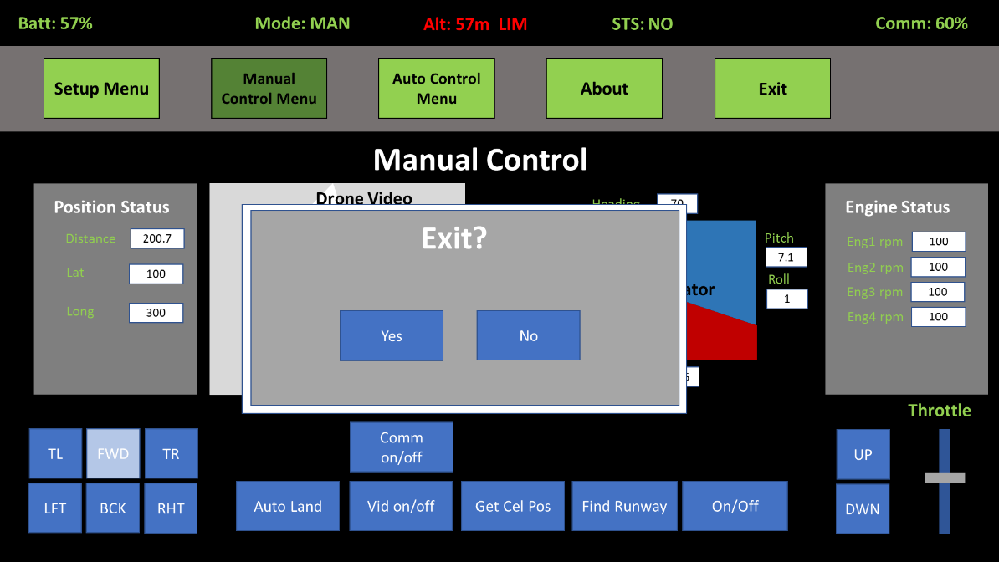

**Figure 4 – Exit Menu**

The setup menu shall allow to set the following parameters for the user input (Keyboard setup):

1. Up key – Set the up command keyboard key for the quad copter via a text box.
2. Down Key – Set the down command keyboard key for the quad copter via a text box.
3. Go left key – Set the go left command keyboard key for the quad copter via a text box.
4. Go right – Set the go right command keyboard key for the quad copter via a text box.
5. Turn left key – Set the turn left command keyboard key for the quad copter via a text box.
6. Turn right – Set the turn right command keyboard key for the quad copter via a text box.
7. Go forward – Set the go forward command keyboard key for the quad copter via a text box.
8. Go backward – Set the go backward command keyboard key for the quad copter via a text box.
9. Throttle up – Set the throttle up command keyboard key for the quad copter via a text box.
10. Throttle down – Set the throttle command keyboard key for the quad copter via a text box.
11. Key sensitivity – Set via a slider controller. The sensitivity setup controls the response time for continuous keyboard commands, such as throttle up or throttle
12. On/Off key – Set the quad copter on/off toggle key.

The setup menu shall allow to set the following communication system parameters:

1. Communication system serial comm port with the range: COM1 – COM4.
2. Communication system operating frequency channel with the range: 0 (2.400GHZ) -124 (2.524 GHZ).
3. Communication system transmission power, with four possible values: 0 – (-18dbm) , 1- (-12dbm), 2- (-6dbm), 3- (0dbm).
4. Communication system address, with the following range: 00000 - 99999

## Manual control menu

The manual control menu shall enable the user to operate the quad copter via manual keyboard commands. The manual control menu is depicted in **Figure 4 - Manual control menu**.

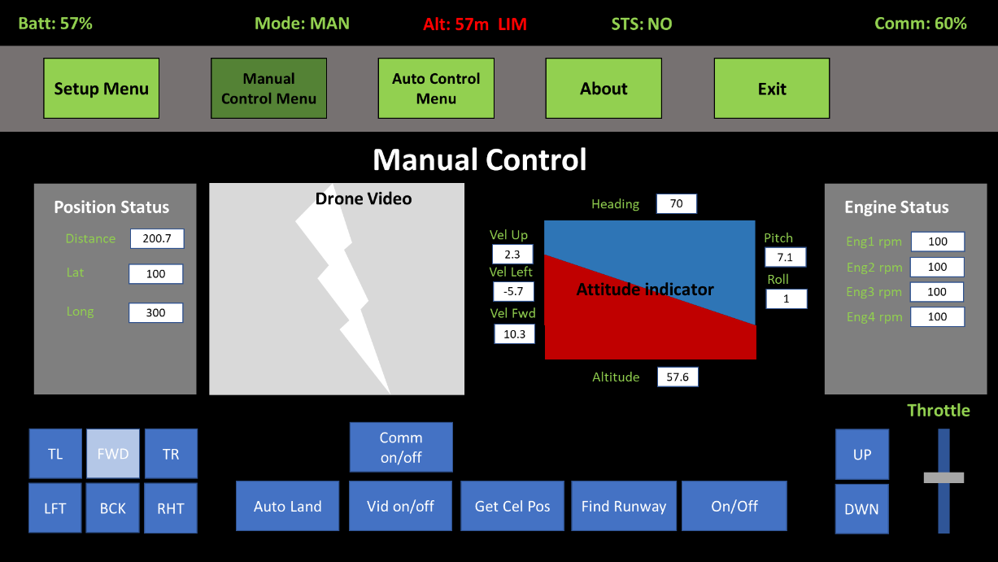

**Figure 5 - Manual control menu**

The manual control menu provides the following reports to the user:

1. Position status reports, which include:
   1. Distance – Provides an absolute value for the distance of the quad copter from the ground controller. The distance is calculated and provided by the quad copter.

**Note:** The distance is calculated from the starting point of the quad copter

* 1. Lat, Long – Provides the estimated latitudes and longitudes of the quad copter. This is to be provided by running the "get celestial position" capability. Or by (provision) GPS position reports from the quad copter.

Range for latitude shall be -90.000000 to +90.000000.

Range for longitude shall be -180.000000 to +180.000000.

1. Engine status reports – RPM percent report for the quad copters four electric motors.
2. Velocity reports –
   1. Forward velocity – Ranging from 999.9 to -999.9 m/s
   2. Left velocity – Ranging from 999.9 to -999.9 m/s
   3. Up/down velocity – Ranging from 999.9 to -999.9 m/s
3. Attitude reports-
   1. Heading – Magnetic heading report – provided in degrees in the following format [xxx.x] - ranging from -180.0 to 180.0.
   2. Pitch report – provided in degrees in the following format [xxx.x] - ranging from -90.0 to 90.0
   3. Roll report – provided in degrees in the following format [xxx.x] - ranging from -180.0 to 180.0.
   4. The attitude report shall also be presented using an attitude indicator.
4. Altitude report – The altitude report shall range from -1,000 to 1,000 meters.
5. Drone video report – Shall display the quad copters FPV video stream.

The manual control menu provides the following controls to the user:

1. The quad copter controller shall provide the following manual commands:
   1. Throttle command – Provides the rate for the quad control commands (e.g go up/down slower or faster, go forward faster or slower).
   2. Go Up command – Shall make the quad copter go up.
   3. Go Down command – Shall make the quad copter fly down.
   4. Go Forward – Shall make the quad copter fly forward.
   5. Go backward – Shall make the quad copter fly backward.
   6. Go left – Shall make the quad copter strafe left.
   7. Go right – Shall make the quad copter strafe right.
   8. Turn right – Shall make the quad copter turn right.
   9. Turn Left – Shall make the quad copter turn left.
   10. On/Off – Turns the quad copters electrical engines on and off. Operates as a toggle key.
2. The above specified command shall be operated by setup defined keyboard keys, or by clicking (mouse down) the button on the screen of the ground controller.
3. The quad copter controller shall also provide the following controls –
   1. Auto land – Shall command the quad copter to land automatically at a constant speed. Pressing the Auto land key shall engage auto land, and pressing it shall disengage auto land.
   2. Get Celestial Position – Shall engage the quad copter in a position finding maneuver, at the end of which a position measurement will be estimated and displayed.
   3. Find runway – Shall engage the optical runway finding function. The function shall mark the runway on the quad copter video display. The function shall also display the position of the quad copter relative to the runway, the glide slope angle and the
   4. Video Feed off – Turns off the display of the video feed from the quad copter.
   5. Comm on off – Turns the quad copter serial communication on/off. Once the system is set to on after being turned off, the communication systems setup parameters are reloaded.

## Auto Control Menu

The automatic control menu shall enable the user to plan and execute automated flight programs for the quad copter. The auto control menu is depicted in **Figure 5 - Auto control Menu**.

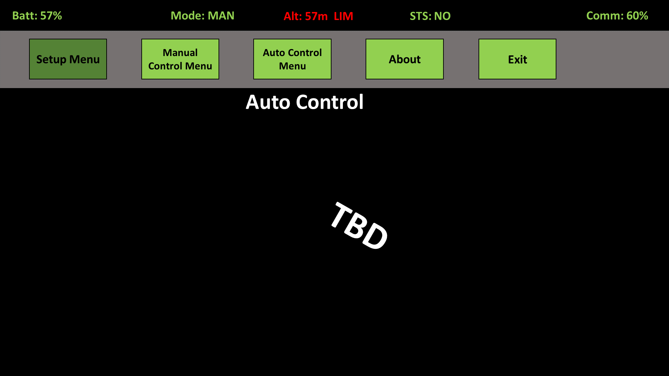

**Figure 6 - Auto control Menu**

The automated control menu is **TBD**.

## About menu screen

The about menu scree shall display the software version of the ground controller and the developers name. The about menu is depicted in **Figure 6 - About Menu**.

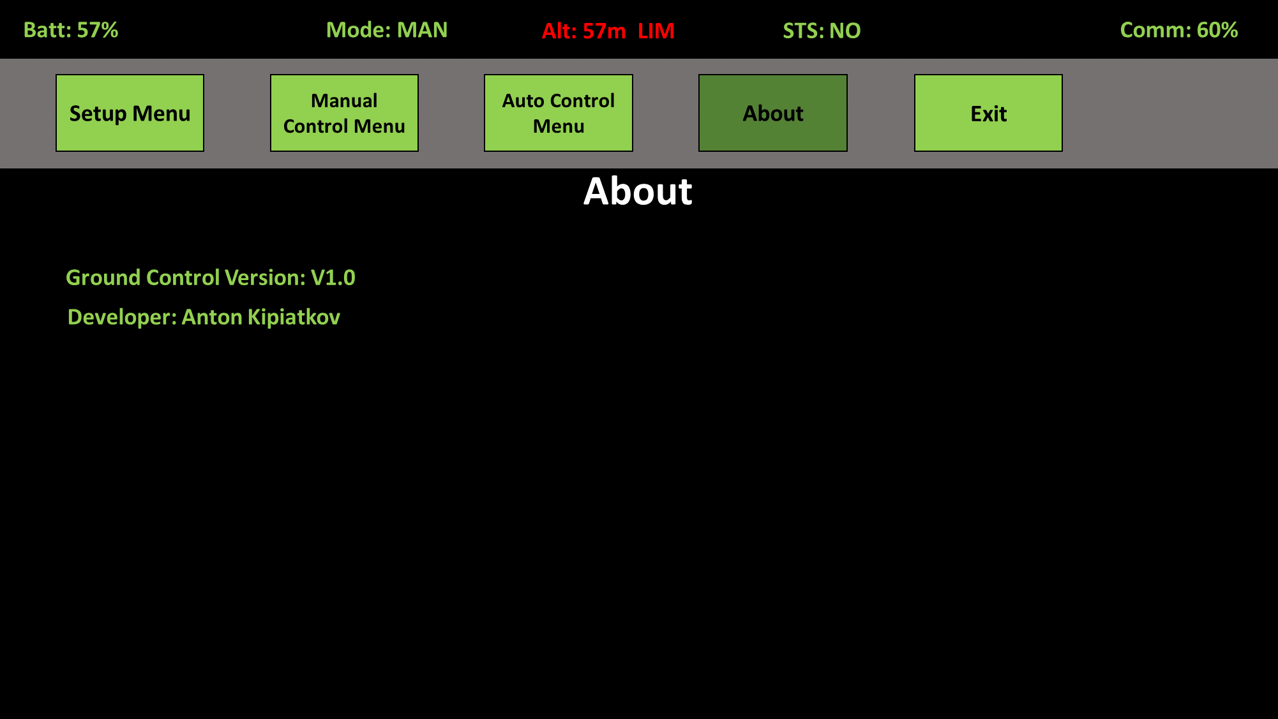

**Figure 7 - About Menu**

# Quad Controls and Setup

## Quad controls

This section describes the quad control concept. The manner the controls are handled by the quad copter is described in detail in the quad copter specification document.

As long as no ON command was sent from the ground controller (i.e. the quad is in off state), the quad copter shall not activate its engines and flight control loops.

On/Off command shall operate as follows:

The quad copter control station shall send an on command to the quadcopter after initialization, this shall command the quad to turn on its electrical engines.

Once an On command was sent the quad system shall operate as follows:

1. The quad copter strives always to remain in a hover state, once a command is received (forwards, upwards, etc.) the quad shall perform the command, but once the command stops the quad shall return to a hover state.
2. Throttle – ranging from 0% to 100% determines the speed of the quad copter in all three axes. Meaning how quickly the quad reacts to the manual control commands.
3. Manual Controls – The ground station allows the following manual control commands to be sent FWD, BACK, LEFT, RIGHT, TURN LEFT, TURN RIGHT, UP, DOWN. Several commands can be sent simultaneously to perform complex maneuvers.
4. Auto functions – Find runway, get cel pos and auto land – Initiate automated functions which are toggled to be on and off. Once a function is completed the automated functionality shall stop. Or if it is stopped manually, the quad shall revert to a hover state.

## Quad control setup handling:

The ground control systems allows the user to setup custom keyboard keys to be used for each type of command and some additional configurations. The setup parameters allow to set the following parameters:

1. Keyboard keys setup for the following controls:
   1. Forward key
   2. Backward key
   3. Left Key
   4. Right Key
   5. Turn right key
   6. Turn left key
   7. Quad on/off toggle key
   8. Go up key
   9. Go down key
   10. Engage/disengage auto land key
   11. Get celestial position key
   12. Enable/disable find runway key
   13. Turn video on/off key
   14. Throttle up key
   15. Throttle down key
   16. Communication on/off key
2. System configurations:
   1. Key sensitivity – How quickly the ground control system reacts to the keyboard input (relevant for throttle inputs).
   2. Log data – Determines whether the ground controller application saves the flight data.
   3. Communication system comm port – defines the serial comm port for the communication system
   4. Communication channel setup – defines the communication system selected frequency channel.
   5. Communication system address - defines the address of the destination device.
   6. Communication system power – defines the communication system transmission power.

The default setup configuration is as follows specified in **Table 1 – Default setup**

|  |  |  |  |
| --- | --- | --- | --- |
| **#** | **Parameter** | **Default value** | **Note** |
| 1 | Forward Key | W |  |
| 2 | Backward Key | S |  |
| 3 | Go left key | D |  |
| 4 | Go right key | A |  |
| 5 | Turn right key | E |  |
| 6 | Turn left key | Q |  |
| 7 | Quad on/off key | O |  |
| 8 | Go up key | UP |  |
| 9 | Go down key | DOWN |  |
| 10 | Auto land key | 1 |  |
| 11 | Get cel pos key | 2 |  |
| 12 | Find runway key | 3 |  |
| 13 | Video on/off key | V |  |
| 14 | Throttle up key | RIGHT |  |
| 15 | Throttle down key | LEFT |  |
| 16 | Comm on/off key | C |  |
| 17 | Key sensitivity | 50 |  |
| 18 | Log data | False |  |
| 19 | Comm port | COM4 | 3 == “COM4” – UNO default |
| 20 | Comm frequency | 108 | Channel above most wifi channels |
| 21 | Comm address | 1 |  |
| 22 | Comm power | 3 | 0 – Minimal power (-18dbm)  3 – Maximal power (0dbm) |

Table 1 – Default setup

The setup shall be saved in a setup.txt file. The following are the allowed keyboard setup keys: “**SPACE**”, “**,**”, “**’**”, “**-**“, “**.**”, “**/**”, “**0**”, “**1**”, “**2**”, “**3**”, “**4**”, “**5**”, “**6**”, “**7**”, “**8**”, “**9**”, “**;**”, “**=**”, “**A**”, “**B**”, “**C**”, “**D**”, “**E**”, “**F**”, “**G**”, “**H**”, “**I**”, “**J**”, “**K**”, “**L**”, “**M**”, “**N**”, “**O**”, “**P**”, “**Q**”, “**R**”, “**S**”, “**T**”, “**U**”, “**V**”, “**W**”, “**X**”, “**Y**”, “**Z**”, “**[**“, “**\**”, “**]**”, “**UP**”, “**DOWN**”, “**LEFT**”, “**RIGHT**”, “**LALT**”, “**RALT**”, “**LCTRL**”, “**RCTRL**”, “**LSHIFT**”, “**RSHIFT**”, “**ENTER**”, “**TAB**”, “**ESC**”.

Each key must have a unique keyboard setup value. The system shall not check the correctness of the setup file.

# Digital communication link function

## General communication system description

This section provides a general description of the quad ground controllers digital communication system. The main purpose of the communication system is to send digital command and receive acknowledges and status messages from the quad copter.

The digital communication system is composed of three main electrical components:

* An Arduino UNO board – Which is used as the controller for the communication system.
* A NRF24L01-PA-LNA board – This board is used to send/receive digital data to/from the quadcopter over 2.4Ghz channel (Shared with WIFI and publicly available).
* A PA-LNA antenna connected directly to the NRF24L01 board.

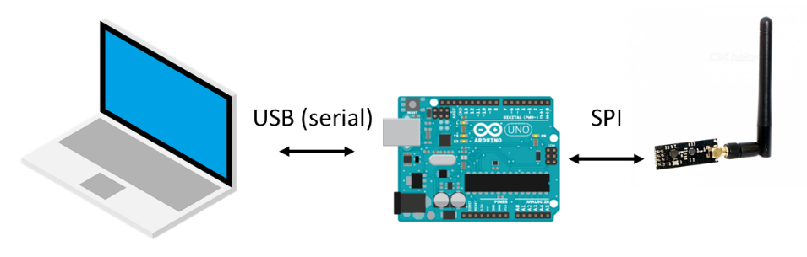

**Figure 8 – Digital Communication system architecture**

The architecture of the system is depicted in **Figure 8** . The PC laptop is connected to the Arduino board via a USB cable. Via the USB connection the PC sends the command messages to the Arduino board and controls the communication system, the Arduino sends received status messages to the PC. The Arduino board is connected to the NRF24L01 communication via a serial peripheral interface (SPI). The Arduino board sends the commands received from the PC to the communication module to be sent to the quad copter and receives data received by the communication module.

For the most part the PC creates and unpacks the messages to be sent or messages received from the communication segment. The other components just pass through the received data.

## Ground control station signal interface

### General definitions

The general structure of a message sent or received by the communication system is as described in Table 2 – General Message structure.

|  |  |  |
| --- | --- | --- |
| **Field** | **Size [Bytes]** | **Description** |
| Begin Transmission field | 1 | Always set to 0xFF  Used to indicate the start of a message transmission |
| Message length | 1 | Indicates the length of the message, excluding the length and begin transmission fields |
| Message ID | 1 | This field defines the structure and function of the sent/received message. |
| Sequence number | 1 | A rolling number incremented by one per each message sent. Only relevant for data to be forwarded to the RF link. |
| Data Payload | - | A filed of varying length which structure is defined by the message ID. |
| CRC | 1 | A CRC-8 Field calculated for the message data from the message ID to the end of the data payload |

Table 2 – General Message structure

The physical characteristics of the communication system are: The data is divided into 8 bit words, no parity and one stop bit. The baud rate for the data transfer is 115,200.

Description of the physical interface – Serial , baudrate

### TX message description (Ground station -> Quad)

The following are the messages sent from the ground station to the quad copter via the communication system:

**Message 1: Status Request**

The status request message shall be sent by the ground controller to the quad copter when no manual or automatic commands are being generated by the ground controller, i.e. when the ground controller is not operated via the manual or automatic menu (automatic menu is TBD) or when the manual menu is in OFF state. The structure of the message is described in Table 3 - States Request Message.

|  |  |  |  |  |
| --- | --- | --- | --- | --- |
| **Position[Bytes]** | **Field** | **Size [Bytes]** | **Value** | **Description** |
| 0 | Begin Transmission field | 1 | 255 (0xFF) | - |
| 1 | Message length | 1 | 4 | - |
| 2 | Message ID | 1 | 10 | - |
| 3 | Sequence number | 1 | As defined by the protocol. | A rolling number incremented by one per each message sent. |
| 4 | Status code | 1 | 0 | Reserved for future use. |
| 5 | CRC | 1 | CRC-8 | - |

Table 3 - States Request Message

**Message 2: Manual command**

The manual command message shall be sent by the ground controller to the quad copter when the ground controller is operated via the manual menu, i.e. the manual menu is selected and is in ON state. The message shall be sent continuously. The manual command message is described in Table 4 .

|  |  |  |  |  |
| --- | --- | --- | --- | --- |
| **Position [Bytes]** | **Field** | **Size [Bytes]** | **Value** | **Description** |
| 0 | Begin Transmission field | 1 | 255 (0xFF) | - |
| 1 | Message length | 1 | 5 | - |
| 2 | Message ID | 1 | 20 | - |
| 3 | Sequence number | 1 | As defined by the protocol. | A rolling number incremented by one per each message sent. |
| 4 | Man_command | 1 | See Element description in Table 5 | The selected manual commands to be performed |
| 5 | Throttle | 1 | 0 to 100 | 0 = do not react  100 = fastest response to commands |
| 6 | CRC | 1 | CRC-8 | - |

Table 4 - Manual command message

The following table provides the bit by bit description of the man_command element in the manual command message:

|  |  |  |  |
| --- | --- | --- | --- |
| **Field** | **Bit** | **Value** | **Description** |
| go_forward | 0 | 0 or 1 | 0 = Do nothing  1 = Fly forward |
| go_back | 1 | 0 or 1 | 0 = Do nothing  1 = Fly backward |
| turn_left | 2 | 0 or 1 | 0 = Do nothing  1 = Turn Left |
| turn_right | 3 | 0 or 1 | 0 = Do nothing  1 = Turn right |
| go_left | 4 | 0 or 1 | 0 = Do nothing  1 = Fly left |
| go_right | 5 | 0 or 1 | 0 = Do nothing  1 = Fly right |
| go_up | 6 | 0 or 1 | 0 = Do nothing  1 = Fly up |
| go_down | 7 | 0 or 1 | 0 = Do nothing  1 = Fly down |

Table 5 - man_command element description

**Message 3: Special commands**

The special command shall be sent from the ground controller to the quad if the ground controller is operated from the manual menu and if the menu is in ON state and if a special function is activated:

* Auto land function
* Get position function

The special commands message is described in

|  |  |  |  |  |
| --- | --- | --- | --- | --- |
| **Position [Bytes]** | **Field** | **Size [Bytes]** | **Value** | **Description** |
| 0 | Begin Transmission field | 1 | 255 (0xFF) | - |
| 1 | Message length | 1 | 4 | - |
| 2 | Message ID | 1 | 30 | - |
| 3 | Sequence number | 1 | As defined by the protocol. | A rolling number incremented by one per each message sent. |
| 4 | special_cmd | 1 | See Element description in Table 7 | The selected special command to be performed |
| 5 | CRC | 1 | CRC-8 | - |

Table 6 - Special commands message

The following table provides a bit by bit description of the special_cmd element in the special commands message:

|  |  |  |  |
| --- | --- | --- | --- |
| **Field** | **Bit** | **Value** | **Description** |
| auto_land | 0 | 0 or 1 | 0 = Do nothing  1 = Perform auto landing |
| get_pos | 1 | 0 or 1 | 0 = Do nothing  1 = Perform get position maneuver |

Table 7 - Special_cmd element description

**Message 4: Setup command**

The setup command shall be sent from the quad controller application to the serial communication system. This command defines the setup parameters of the serial communication system. The content of the message is described in Table 8.

| **Position [Bytes]** | **Field** | **Size [Bytes]** | **Value** | **Description** |
| --- | --- | --- | --- | --- |
| 0 | Begin Transmission field | 1 | 255 (0xFF) | - |
| 1 | Message length | 1 | 6 | - |
| 2 | Message ID | 1 | 253 | 253 Reserved value for setup message ID |
| 3 | Tx_address | 1 | 0 - 255 | - |
| 4 | Rx_address | 1 | 0 - 255 | - |
| 5 | Selected_RF_channel | 1 | 0 - 125 | For frequency range of:  2.400 to 2.525 [GHz] |
| 6 | Power | 1 | 0 – 3 | 0 for -18dBm, 1 for -12dBm, 2 for -6dBm and 3 for 0dBm |
| 7 | CRC | 1 | CRC-8 | - |

Table 8 - Setup command

### RX message description (Quad -> Ground station)

The following are messages sent by the quad copter to the quad ground controller.

**Message 1: Acknowledge (ACK) message**

The ACK message is sent by the quad copter to the ground controller as a response to a received message. The ACK message allows the ground controller to know that the message was received by repeating the received sequence_number back to the ground controller. Additionally, the quad provides some important information about its status via the ACK message. The contents of the acknowledge message are described in Table 9.

|  |  |  |  |  |
| --- | --- | --- | --- | --- |
| **Position[Bytes]** | **Field** | **Size [Bytes]** | **Value** | **Description** |
| 0 | Begin Transmission field | 1 | 255 (0xFF) | - |
| 1 | Message length | 1 | 23 | - |
| 2 | Message ID | 1 | 11 | - |
| 3 | Sequence number | 1 | As defined by the protocol. | A rolling number incremented by one per each message sent. |
| 4 | Battery_status | 1 | 0 to 100 | 0 = Battery empty  100 = Battery full |
| 5 | Velocity_up | 2 | -32,768 to 32,767  (signed 2 byte) | -32,768 = -999.99  32,767 = 999.99 |
| 7 | Velocity_left | 2 | -32,768 to 32,767  (signed 2 byte) | -32,768 = -999.99  32,767 = 999.99 |
| 9 | Velocity_forward | 2 | -32,768 to 32,767  (signed 2 byte) | -32,768 = -999.99  32,767 = 999.99 |
| 11 | Heading | 2 | -32,768 to 32,767  (signed 2 byte) | -32,768 = -180.0  32,767 = +180.0 |
| 13 | Altitude | 2 | -32,768 to 32,767  (signed 2 byte) | -32,768 = -1,000  32,767 = +1,000 |
| 15 | Pitch | 2 | -32,768 to 32,767  (signed 2 byte) | -32,768 = -180.0  32,767 = +180.0 |
| 17 | Roll | 2 | -32,768 to 32,767  (signed 2 byte) | -32,768 = -180.0  32,767 = +180.0 |
| 19 | Eng1_sts | 1 | 0 to 100 | 0 = 0% RPM  100 = 100% RPM |
| 20 | Eng2_sts | 1 | 0 to 100 | 0 = 0% RPM  100 = 100% RPM |
| 21 | Eng3_sts | 1 | 0 to 100 | 0 = 0% RPM  100 = 100% RPM |
| 22 | Eng4_sts | 1 | 0 to 100 | 0 = 0% RPM  100 = 100% RPM |
| 23 | Fault_status | 1 | See element description in table 9 | 8 bits describing faults reported by the quad |
| 24 | CRC | 1 | CRC-8 | - |

Table 9 – Acknowledge message

The following table describes the fault_status element reported by the quad copter:

|  |  |  |  |
| --- | --- | --- | --- |
| **Field** | **Bit** | **Value** | **Description** |
| Gyro_fail | 0 | 0 or 1 | 0 = Normal operation  1 = Failure |
| Accelerometer Fail | 1 | 0 or 1 | 0 = Normal operation  1 = Failure |
| Mag Heading fail | 2 | 0 or 1 | 0 = Normal operation  1 = Failure |
| Eng1_fail | 3 | 0 or 1 | 0 = Normal operation  1 = Failure |
| Eng2_fail | 4 | 0 or 1 | 0 = Normal operation  1 = Failure |
| Eng3_fail | 5 | 0 or 1 | 0 = Normal operation  1 = Failure |
| Eng4_fail | 6 | 0 or 1 | 0 = Normal operation  1 = Failure |
| Reserved | 7 | N/A | N/A |

Table 10 - Fault_status element description

**Message 2: Setup Acknowledge (ACK) message**

The setup ACK message is sent by the serial communication system as a response to a correctly received setup message. The content of the setup ACK message is described in table #.

| **Position [Bytes]** | **Field** | **Size [Bytes]** | **Value** | **Description** |
| --- | --- | --- | --- | --- |
| 0 | Begin Transmission field | 1 | 255 (0xFF) | - |
| 1 | Message length | 1 | 3 | - |
| 2 | Message ID | 1 | 254 | 254 Reserved value for setup ACK |
| 3 | Setup_ack_status | 1 | 0 – Fail  1 - OK | Describes the initialization status of the communication system. |
| 4 | CRC | 1 | CRC-8 | - |

Table 11 - Setup Acknowledge message

### Protocol description

This section describes the communication protocol between the ground controller and the quad copter (See **Figure 9**):

1. The protocol sequence re-starts each time the communication function is turned on by the quad controller application.
2. Once the communication function starts it first sends a setup message to the communication system and waits for a setup acknowledge for 500[ms]. If no setup Ack arrives, the application resend the setup message and waits again for 500[ms] for a setup ACK message. If no message arrives once more the communication function shuts down.
3. Once the setup was sent and accepted, the quad copter ground controller sends a message to the quad periodical, with a cycle time of 50 [msec].
4. The message sent is determined as follows:
   1. If
   2. If not in manual menu OR in manual menu AND on_off button is in off state, send a status request message (Message ID == 10).
   3. If in manual menu AND on_off button is on AND auto_land button and get_pos button are in off state, send a manual command message (Message ID == 20).
   4. If in manual menu AND on_off button is on AND get_pos button OR auto_land buttons are on, send a special command message (Message ID == 30).
5. Each message sent, is sent with a sequence number of 1 byte in size, the value ranging from 0 to 255. The sequence number is incremented by 1 with each message sent. When the number reaches 255, the sequence number rolls over to 0.
6. The quad copter receives a command message from the ground controller and responds immediately with an acknowledgement(ACK) message. The ACK is sent with a sequence number identical to the last received one.

Note: The sequence number is used for development purposes.

Note 2: It is assumed that the quad copter responds to the command message immediately, and the time it takes the message to arrive and be read is less than the communication cycle time.

Note3:The maximal message size is 32 bytes.

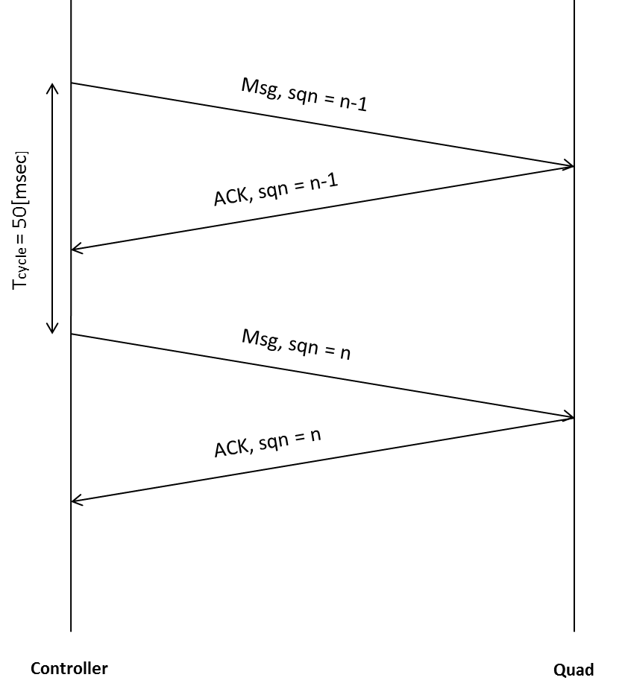

**Figure 9 – Communication protocol timeline**

## Communication system function description

Data transaction

This section describes the full transaction of data on the ground station side. The data to be sent, which is defined in section ‎8.1.2, is prepared by the PC. The PC sends the data every communication data cycle as defined in section ‎8.1.4. The data is sent to the serial communication system over a serial USB port.

The Arduino receives the information from the PC over USB and sends it to the RF unit. Additionally, the Arduino receives messages from the RF unit and sends them over the USB connection to the PC. At any given point in time the RF module is either transmitting data or receiving data, but never both simultaneously. The data flow within the communication systems components is depicted in **Figure 10**.

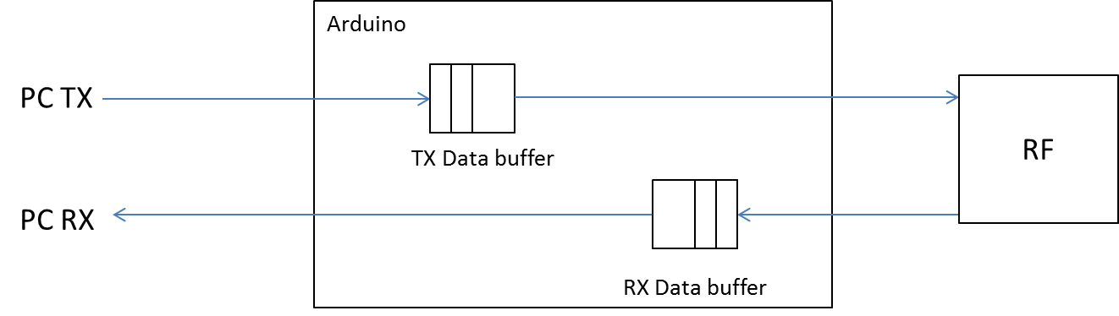

**Figure 10 – Communication system internal data flow**

For the communication function description of the serial communication system refer to the “Serial Communication System Specification” document.

Communication status

In parallel to performing the data transaction, the ground controller is also monitoring the status of the communication link. This is performed in order to present a communication quality indicator in the ground controller status bar indicated as "**[Comm: ###%]**" in the upper right corner of the screen.

The communication quality percentage indicator is calculated as follows:

1. The application uses three variables to calculate the communication system status:
   1. **sent_counter** – Which counts the number of messages sent. This counter initialized to 0 at startup and reset to 1 once it reaches above 50.
   2. **rec_counter** - Which counts the number of messages received. This counter is thresholded at 50, and reset to 0 when the **sent_counter** reaches above 50.
   3. **comm_status** – which holds the last computer communication status. comm_status is initialized to 100.
2. The communication status is updated and calculated as follows:
   1. Each time a message is sent the sent_counter is incremented by one.
   2. Each time a valid message is received the rec_counter is incremented by one. The rec_counter value is threshold value is 50.
   3. If sent_counter reached 50, the comm_status is updated as follows: comm_status = 100*(rec_counter/sent_counter).
   4. After the comm_status value is updated and stored, the counters are set as follows: sent_counter = 1, rec_counter = 0.

Thus the communication status value is updated by the system roughly every 1[sec].

Communication Initialization –

Communication system initialization is performed each time the communication link is turned on or off via the comm on/off button on the manual command screen.

Once turned on the following parameters are setup for the communication system:

* The communication TX address.
* The communication RX address.
* The selected RF frequency.
* The communication system transmission power.

All four parameters are stored in the system setup file, and are read each time the setup of the system is reconfigured. The parameters are sent via a serial setup command.

# Ground Control Initialization – #TODO

This section describes the initialization sequence of the ground control application upon first loading.

# Quad Health Monitor

# Video Link function

## Video receiver description

## Video link functional description

# Runway recognition function

# Position Estimation function

# Autoland function

# Autoland on runway - TBD

# Automated flight execution

# Mechanical design description – Schematics, assembly, etc…

# Electrical ICD – Wiring DWGs for production...

# List of abbreviations